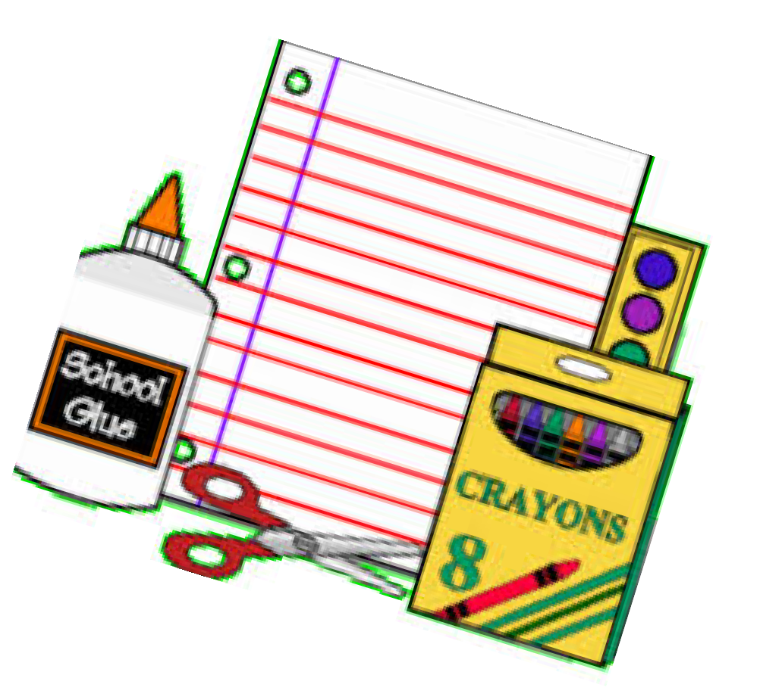

GRADE 6 SUPPLY LIST

20 HB pencils (made in Canada or USA)
- red pens
- blue pens
1 pencil crayons (24)
- felt pens (12) (Fine Tipped unscented)
- highlighters
5 white erasers
2 glue sticks (20g)
1 2” binder
5 duotangs – multicoloured
3 coil notebooks, 100 pages lined
1 soft pencil case
1 pencil sharpener
1 large scissors-pointed
- metric ruler-non bendable (metric/imperial)
- graphing (grid) notebooks
- Geometry Set
- Sharpies
6 3x3” Post it Notes
4 80 page 4x1” Graph Scribbler
4 whiteboard markers
1 solar powered calculator

Additional items:
1 headphones
1 pair indoor non-marking running shoes (suitable for athletics)

Please note white-out will not be allowed in the classroom.

